

**CIND 820**

Project Report

Student Name: Ryan Boyd

Student Number: 501072988

Date Submitted: 3/28/2022

Project Supervisor: Dr. Ashok Bhowmick

**Introduction and Project Goal**

This project aims to discriminate unique objects from a LiDAR point cloud dataset which was collected from an aerial aircraft in 2016 and has been provided free of charge through the city of Vancouver’s open data portal website. LiDAR data is commonly used to create precise elevation models of the earth’s surface and to detect the surrounding environments for self driving vehicles. Point clouds returned by LiDAR sensors do not inherently differentiate anything in the data, they typically simply collect and store the laser pulse return information, which is processed to return some characteristics of the reflected surface. These characteristics include the distance to the surface, the intensity or brightness of the returned pulse, scan angle and the number of pulses that were returned (for cases where the laser partially hits a surface and continues to travel). This project will investigate whether unsupervised learning methods such as clustering can be used to identify any distinguishable features from the data. The capability to identify and even count unique features using LiDAR could be a useful practice for several reasons including asset management and tracking, scenery reconnaissance, object detection and avoidance (on vehicle mounted devices for example), robot vision, environmental or vegetation growth studies, building development studies among many more. Distinguishing and counting unique objects from the data can also prove to be a useful step in classifying and categorizing the scenery in combination with other methods.

**Research Question**

“Can unique objects be distinguished from lidar data point clouds using clustering tools?”

**Github Repository**

<https://github.com/rboyd-ryerson/CIND820>

**Existing Research Literature**

There were several research papers on the subject matter, many of which contained more advanced topics which I have not attempted to replicate. The concepts, however, are very similar and I have used many of the ideas in my project. For example, in the paper “Airborne Lidar Feature Selection For Urban Classification Using Random Forests” by Nesrine Chehata, Li Guo and Clément Mallet, they extracted the ground and off-ground features by differentiating the lowest points, which is similar to the method I have used. I also used the idea for random forests from this paper, to reclassify the ground points to improve the classification. This paper also mentions the use of eigenvalue-based feature detection, which I was interested in applying but did not end up pursuing, perhaps in the future I would like to examine this.

The idea of edge detection was also mentioned in the paper “Adaptive Building Edge Detection By Combining Lidar Data And Aerial Images” by LI Yong, WU Huayi, where they use aerial imagery to detect buildings. I was inspired by this idea to incorporate the imagery, however I did not achieve great results due to certain limitations in the data such as shadows.

In the paper titled “Semi-Automated Approach For Mapping Urban Trees From Integrated Aerial Lidar Point Cloud And Digital Imagery Datasets” by Dogon-yaro, M., Kumar, Pankaj, Rahman, Alias and Buyuksalih, G., they also used imagery in combination with lidar to attempt to classify vegetation. The NDVI was a calculation I considered to extract the vegetation, but needed the NIR data which was not provided, this paper also explored the negative drawbacks of shadows in the imagery.

Several other papers included useful information as well that I gained insight from including:

“Machine Learning Algorithms and Applications for Lidar, Images, and Unstructured Data” by Biswas Parajul – focuses on road segmentation and covers more advanced algorithms.

“A Knowledge-based Approach to Urban Feature Classification Using Aerial Imagery with Lidar Data” by Ming-Jer Huang, Shiahn-Wern Shyue, Liang-Hwei Lee, and Chih-Chung Kao gave me the idea to use rule-based criteria to attempt to define the classes, but this proved to make things too complicated and not enough data was available to me to implement further.

“Automated Building Detection Using Ransac From Classified Lidar Point Cloud Data” by D.L. Bool, L.C. Mabaquiao, M.E. Tupas and J.L. Fabila as well as "Aerial Point Cloud Classification With Deep Learning And Machine Learning Algorithms” by E. Özdemir, F. Remondino and A. Golkar were some other interesting classification research studies which used several machine learning/deep learning techniques such as CNN, RNN and RANSAC, which I was not familiar with and did not attempt to replicate, though the information within the study was still valuable.

**Data**

The lidar dataset was acquired from the City of Vancouver’s Open Data Portal as an LAS filetype. It contained 2 million points from an area of approximately 2.54 square km. There were **20,975,490** data points in total. These data points were read into a pandas dataframe using the ‘laspy’ library. It was too large to work with so a smaller area was then chosen.

The dataset was “clipped” to a smaller containment area of interest by querying the coordinates in the data frame to within the desired extent. After clipping the points to the area of interest, there were **864,412** points remaining in an area of 93,330 square meters.

The horizontal projection coordinate system of the data is NAD83 UTM10 which represents the coordinates as meters from the equator for the latitude (Y) and meters from the Central Meridian in Greenwich for the longitude (X).

An aerial orthophoto of the same area was also obtained from the City of Vancouver’s open data portal site to extract the R,G,B values and to visualize the area as a reference. This image was clipped using open source mapping software QGIS to clip to the same extent coordinates as the point cloud data.

The point data contains the following attributes:

|  |  |  |
| --- | --- | --- |
| Field | Description | Datatype |
| X | X Longitude Coordinate | Double |
| Y | Y Latitude Coordinate | Double |
| Z | Z Elevation | Double |
| Intensity | Strength of returned laser pulse | Integer |
| Return Number | Return number of the given point | Integer |
| Total Number of Returns | All returns generated from the given pulse | Integer |
| Classification | Provided classification (ground,unclassified) | Integer |

Dataset description:

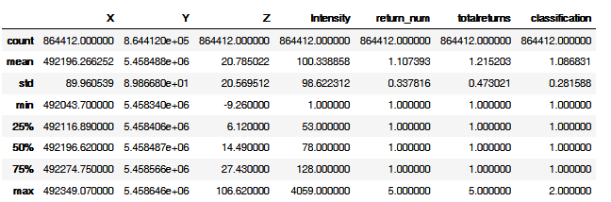

**Multiple Model Approach**

For the purposes of the project, I will use multiple different models to achieve the results. The reason for this is to test multiple models and to gain experience in more than just one. It is common practice in many areas to combine approaches to improve upon the results of just a single approach and this is what I have intended to do.

|  |  |  |  |
| --- | --- | --- | --- |
| **Model** | **Purpose** | **Inputs** | **Parameters** |
| Random Forest Decision Tree | Classify the ground points using provided ground points as label | Height  Intensity  Return Ratio | Leaf Size |
| K-Means Clustering | Cluster the points by height, intensity and return number | Height  Intensity  Return Ratio | K (number of clusters) |
| DBSCAN | Cluster the points by proximity to extract unique features | X  Y  K-means cluster id | Eps  Min_points |

**Methodology - Preprocessing**

*Data loaded and examined*

The first step was to import the dataset and store it into a Pandas Data Frame to be visualized in table form. Since the data contains geographic coordinates, it can easily be visualized on a plot which accurately represents the real-world locations.

Data frame sample:

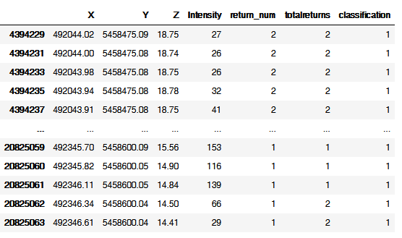

Dataset plot:

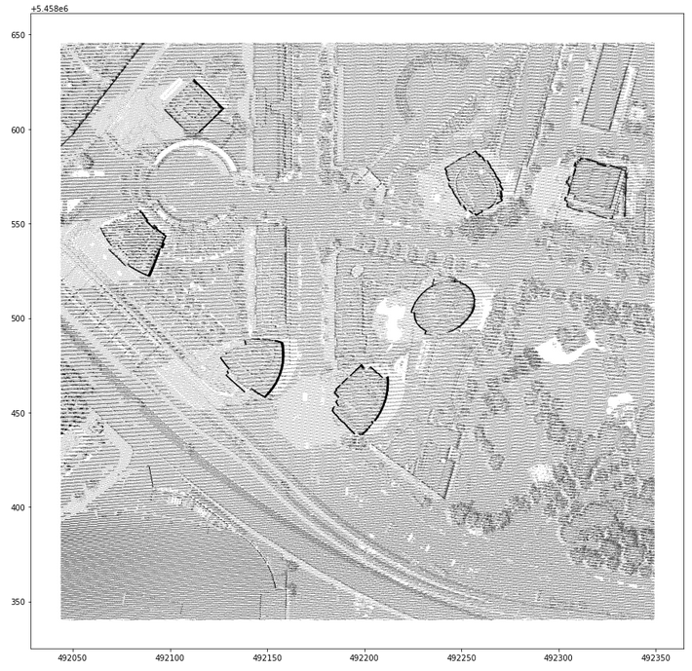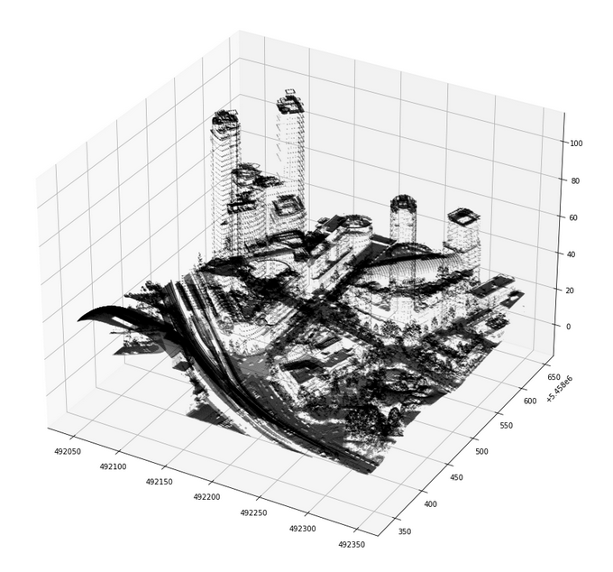

X and Y values plotted X, Y and Z values plotted

*Exploratory analysis*

The data was inspected to visualize the distributions of the points.

|  |  |
| --- | --- |
| X |  |
| Y |  |
| Z |  |
| Intensity  *Values were skewed due to high outliers |  |
| Return Number |  |
| Total Returns |  |

*Cleaning and manipulation*

Some of the data needed to be processed before running the models. The intensity values as an example needed to be rescaled since it was observed that 92.4% of the values were below 200, while the remaining were somewhere between 200 and 4000. These high values were simply cast to be a maximum of 200. This would essentially group any values above 200 to the same value, which for the purposes of this project was deemed to be acceptable.

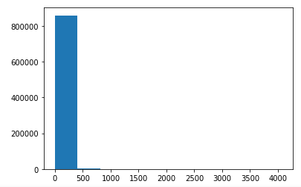 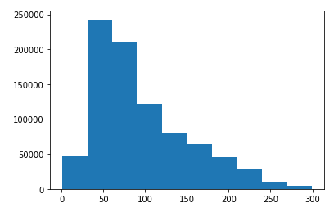

Intensity Histogram before Intensity Histogram after

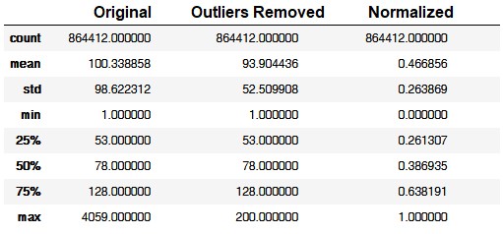

Processed and Normalized Intensity values

*New attribute created for multi return pulses*

In order to simplify the operations a bit, a new attribute was created to combine the 2 existing attributes of “return count” and “total returns”. This new attribute was called return_ratio which is simply “return_number” divided by “total_returns”. This results in values from 1/5 to 1. The values of 1 represent the last points returned by each pulse.

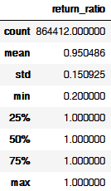

*Height attribute created*

The Z value provided in the dataset provides an absolute height of the objects, however it would be better to use a relative height to the ground. A “DEM” image was provided with the dataset which is an image of the ground where each pixel represents the elevation. The value of each pixel can be subtracted from the Z value of any point at it’s location to obtain the “Height” value which is used in the models instead. To align the data to the image, I rescaled the data to match the size of the image, and used the python PIL library to extract the pixel value from the rescaled coordinates of the image. This method was also used to extract the R,G,B values from an orthophoto as described below. The formula below describes how the values are scaled, this works because the coordinates are scales to between 0 and 1, then multiplied by the image size. This is done for each of the X coordinates, and then again on the Y coordinates.



The pixel value from the image is recorded for each lidar point. The height is then calculated by subtracting the pixel value from the original Z elevation value.

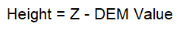

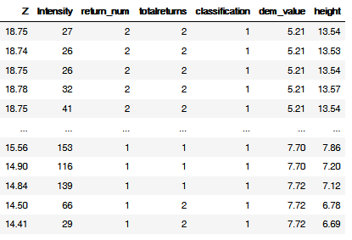

*R,G,B value attributes created from imagery*

An aerial photograph was also obtained and imported into the dataset. By scaling the data to fit the image, in a similar way as the DEM, the RGB values of the lidar points were obtained. Due to the shadows obstructing much of the image, difference in age from data collection by ~ 1 year and that the values did not greatly improve the results, these values were not used to train the model. I looked into altering the values to remove the effect of the shadows but this proved to be time consuming and I did not pursue it much further. The image however will be used to provide a visualization of the clusters to identify and assess the detected features.



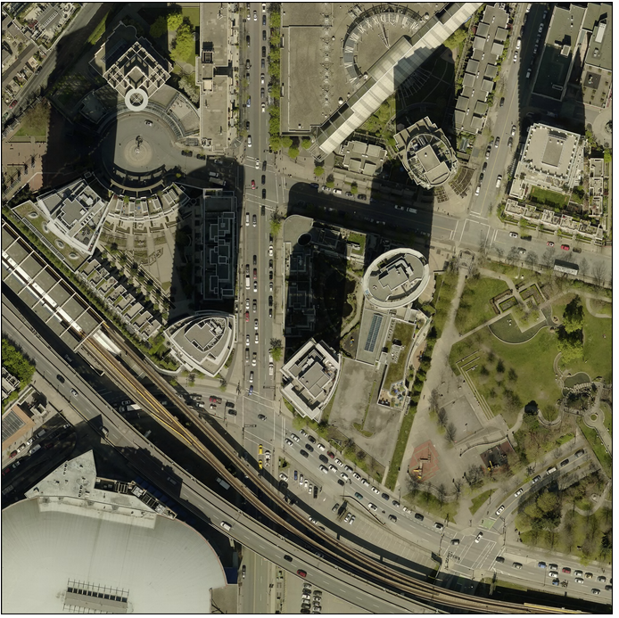 

*Data Normalization*

The data was then normalized on a scale from 0 to 1 to balance the weighting of the attributes in the models. The formula used for this normalization is the following:

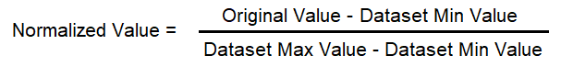

Sample of values after normalization, and data plotted showing new scale from 0 to 1:

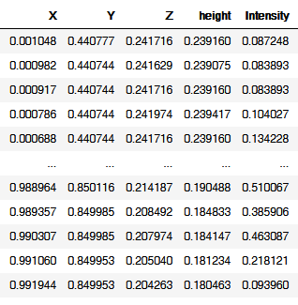 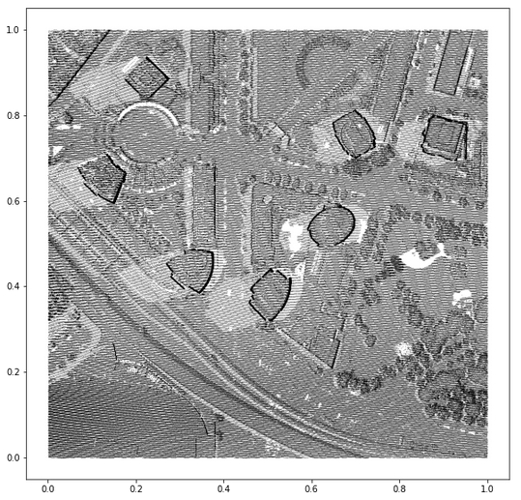

**Methodology – Machine Learning**

*Supervised ground classification*

The data was provided partially classified for the ground points, however upon inspection it did not appear to be complete since most of the areas labeled as ground were still appearing in the locations of unclassified data. I decided to use the provided ground classified points as labels and train a supervised classifier to attempt to classify additional ground points that were still labeled as unclassified.

Before: 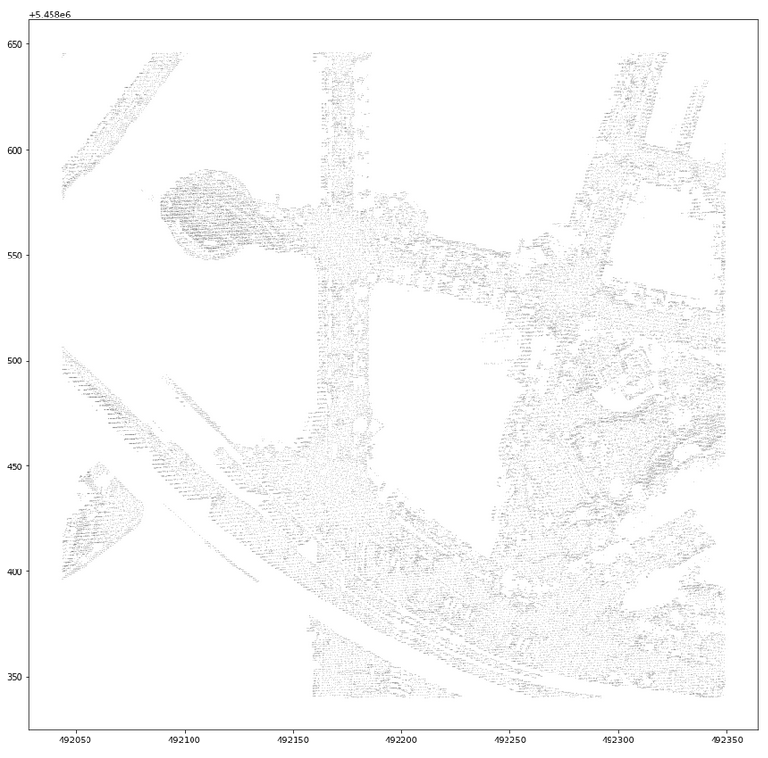 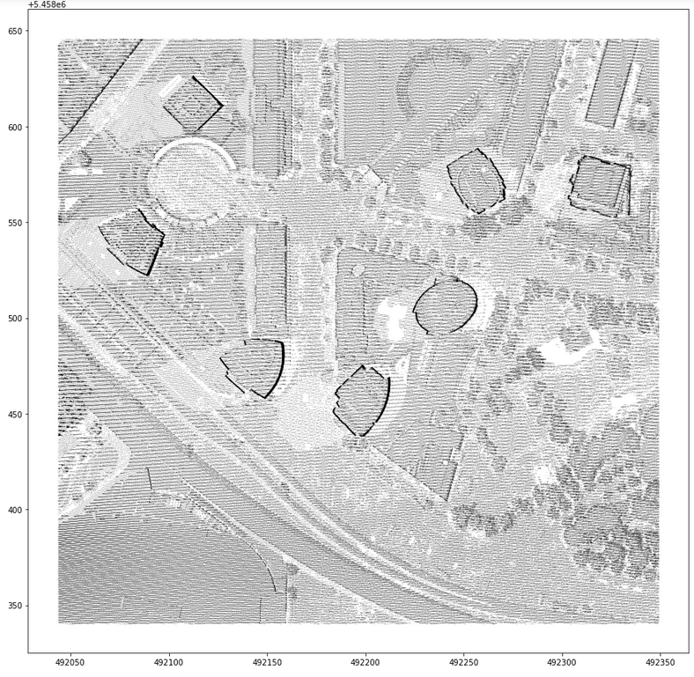

Ground points (as provided) Unclassified points

Data as provided and classified as ground points shown on the left and unclassified points on the right, there is not a clear distinction where the ground is in the image on the right. If this area was ground, it should not remain unclassified and should not still be visible in the unclassified data.

A random forest classifier was used to classify the ground from the unclassified data using the provided ground points as labels.

The data was split into training and test sets using the scikit-learn “split” method. The data was fit to the model using the inputs: intensity, height and return ratio. The points that are identified as “non-ground” will be filtered out and used in the following clustering operations.

*K-means clustering for height and surface type*

The first clustering step was to cluster based on the height and surface type. The features used to train this model were the height, intensity, and the return ratio. The intensity of the pulse and return ratio are used to give indication of the surface type based on the behaviour of the reflected light pulse. This step will essentially classify the points into classes that will then be used in the spatial clustering as an additional input. The K-means algorithm was used to perform this. In order to determine the optimal number of clusters for the value of K, each value was tested and the scores from the silhouette and calinsk-harabsz score were compared. The optimal value of K was found to be 3. The results of this clustering were added to a new field named “k_cluster” and added to the data frame assigning each point to the cluster it was assigned.

*Spatial/Distance Clustering*

The next step was to attempt to cluster the points by their spatial location and the k-means cluster id from the previous step. This will group together the points by proximity, as well as by height and surface type indicated from the k-means cluster id.

The DBSCAN algorithm was used to perform this clustering. The inputs used were the X coordinate, the Y coordinate and the k-means cluster id (k_cluster). The output from this model, will add a new cluster id to each point for the cluster to which it has been assigned similar to the k-means step before. This algorithm will cluster points that are spatially contiguous because of the X and Y coordinates, and are similar in height and surface type based on the k_cluster value.

The model input parameter “eps” refers to the max distance for 2 points to be considered as part of the same cluster, this will prove to be the most important parameter for this model and affect the results significantly. If “eps” is too large, the clusters include too many points and become too large, if “eps” is too small, the clusters would be too small, and too few of the points would end up being included in any cluster.

In order to determine the optimal value for the “eps” parameter value, I found the average distance between all the points to get an idea of the value needed. A Nearest Neighbour algorithm was trained with the feature array as input and graphed to obtain this figure:

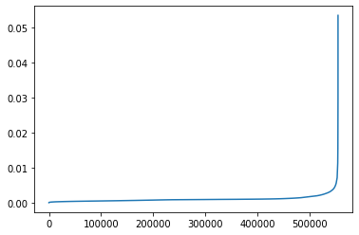This shows the average spacing of all the points of the input features. The location on the Y axis where the elbow or inflection point occurs should provide the best value for the eps parameter because we want a balanced measure of distances to points within each cluster. There is some play in the value as we will see which does influence the final results, such as the size and number of clusters returned. The optimal value of “eps” was found to be between 0.005 and 0.009. This units of this value are actually the normalized values of the input features.

Another parameter of the algorithm is “min_samples”, which is the minimum number of points required for a cluster to form, this was set (arbitrarily) to 50 after several tests were conducted and the number of clusters seemed appropriate. This value is less significant but can limit the number of small clusters that are created if so desired to only locate the larger clusters. If given a higher value, only larger clusters will be returned, the remaining clusters will be discarded and the points unassigned.

*Performance Measures*

To measure the performance of the models, several indicators were used. For the random forest, I used the confusion matrix to calculate the accuracy.

Since labels are not provided for unsupervised data, there is no confusion matrix to be assessed. Instead, 2 common scores can be used. The Calinski-Harabsz score also known as the Variance Criterion Ratio, is a ratio of the average distance of points within each cluster and the average distance between the clusters themselves. The higher the score the better, which means this is more appropriate to compare models given different parameters to test them.

The second score that can be used is a measure of the overlap of all the clusters and is known as the “Silhouette Score”. The silhouette score ranges from -1 indicating a high degree of overlap and 1 indicating there is little overlap and the clusters have been chosen appropriately.

The number of clusters, the total number of points clustered, and the time taken to train each model were also used to assess the performance of the models.

With each model, the parameters were chosen that optimized these performance measures.

**Results and Discussion**

*Best Model training times*

Each model was timed for how long it took to train and fit the data, listed below:

|  |  |
| --- | --- |
| **Model** | **Time** |
| Random Forest Classifier (ground) | 32s |
| K-Means Clustering (Height/Intensity Class) | 3s |
| DBSCAN Clustering (proximity) | 4m 55s |

*Best Achieved Performance Measures*

Each model was assessed based on these scores and the best score was selected in most cases

|  |  |  |  |  |
| --- | --- | --- | --- | --- |
| **Model** | **Cluster Count** | **Total Points Clustered** | **Calinski-Harabsz Score** | **Silhouette Score** |
| K-Means | 3 | 554,877 | 771,834 | 0.56 |
| DBSCAN | 585 | 419,558 | 4,119 | -0.27 |

*Random Forest Ground Classification*

The accuracy score from the model was **0.735** using the test set. The model was then used to predict the ground points for entire dataset. As provided, there were **75,028** points classified as ground in the initial dataset. After my classification there were **301,253** points classified as ground.

|  |  |  |
| --- | --- | --- |
|  | Predicted Non-Ground | Predicted Ground |
| Original Non-Ground | 554640 | 226462 (new) |
| Original Ground | 237 | 74791 |

Confusion Matrix:

Full dataset accuracy: 554640 + 74791 / 856,130 = 0.735

After: 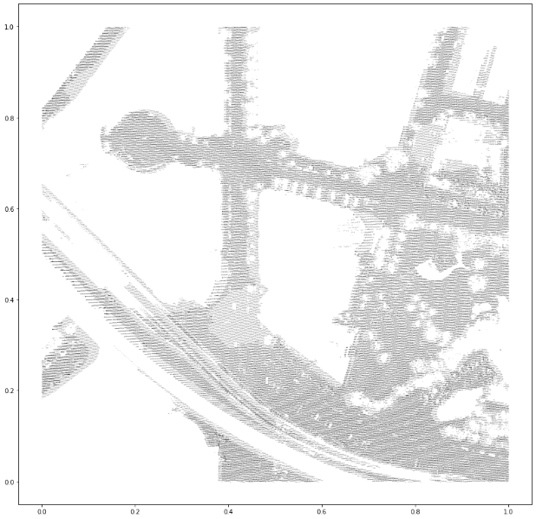 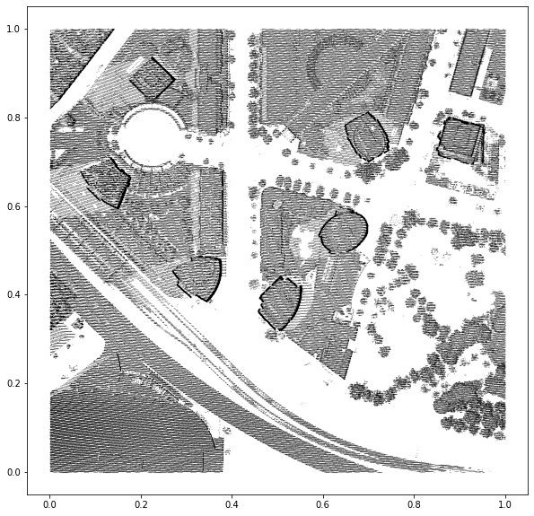

Ground points (newly classified) Non-Ground (unclassified)

The new datasets now show clear distinction between the ground points and non ground points. The unclassified points now will be used to attempt to identify additional objects in the data. There is a total of **554,877** non-ground points that were remaining to be classified/clustered.

*K-Means Clustering – Height and Surface type*

All 554,877 points were clustered into 3 unique clusters with a Calinki-Harabsz score of 771,834. The next best C-H score would have been 731,768 for 4 clusters and 676,329 for 5 clusters. (Since the higher the score, the better the performance of the model, 3 was chosen). The silhouette score was 0.56 which indicates there was not significant overlap. The model took 3 seconds to train.

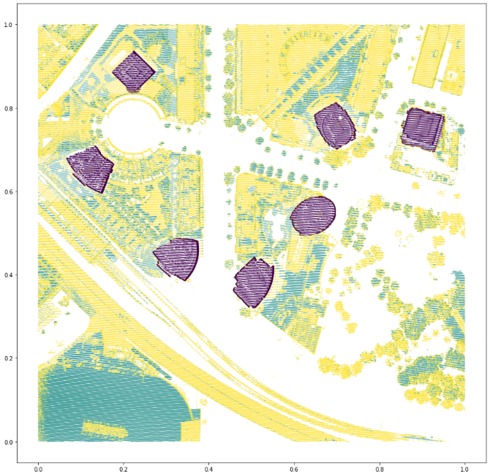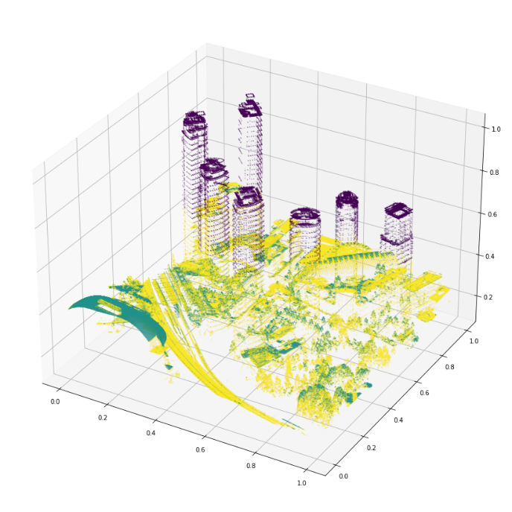

*DBSCAN Spatial Clustering*

The DBSCAN algorithm returned a total of 585 clusters using a total of 419,558 points. The silhouette score was -0.27 which indicates some overlap in the clusters. This is expected however, since the surface of many objects is made up of different material that likely was clustered together. For example, the entire building would certainly overlap with each individual windowpane that was clustered separately. Therefore, the best score of -0.27, which is itself not considered a good score, is not an indication that model performed poorly, but an indication that the performance measure may not be entirely appropriate for the data in question, since cluster overlap is acceptable and expected. Though a worse score might indicate there is an issue to be resolved.

**Visualization**

The results have been visualized in the following images by creating a border around each cluster using a Convex Hull method of matplotlib.

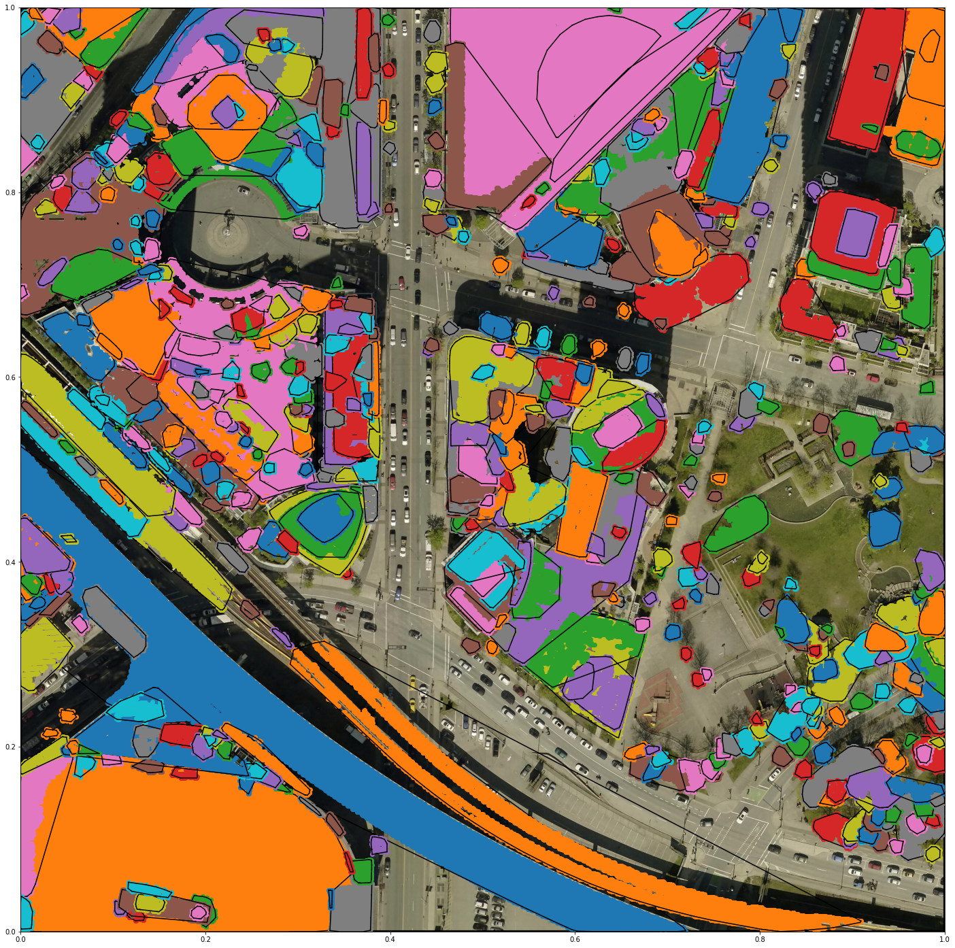

To improve the visualization, the clusters were split into 3 groups based on the size of the clusters.

|  |  |  |
| --- | --- | --- |
| **Cluster Size** | **Points** | **Features** |
| Small | < 500 | 468 |
| Medium | 500 to 2,500 | 88 |
| Large | > 2,500 | 28 |

Small Clusters:

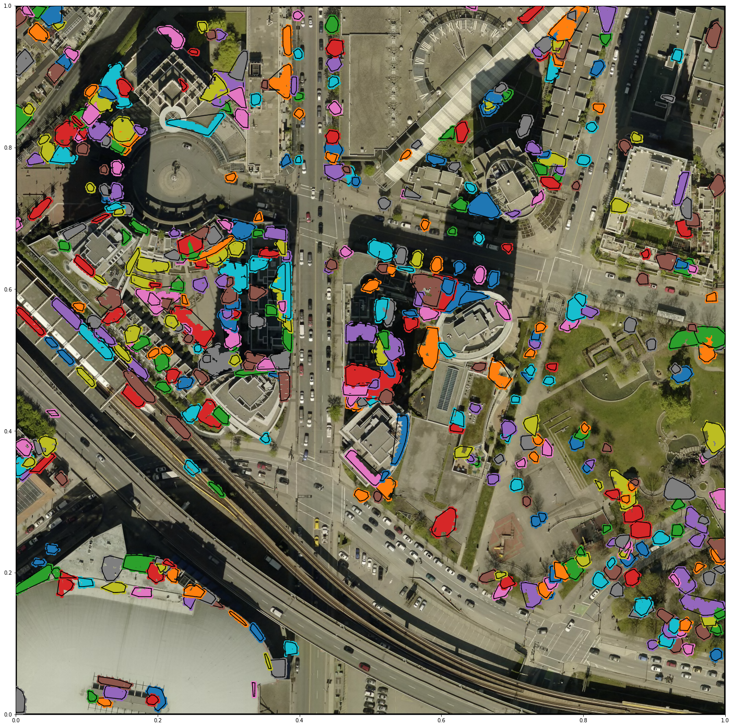

Among these features, there are apparent trees, balconies, rooftop features, windows, among some others.

Medium Clusters:

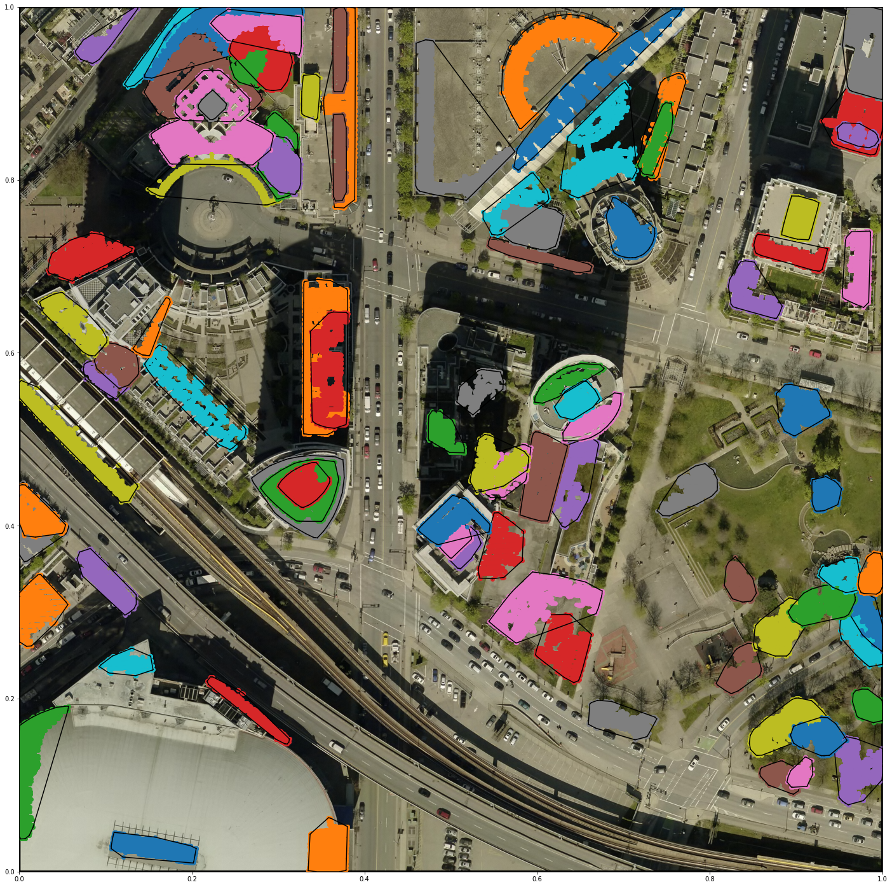

Among these features are building footprints, apartments, larger tree canopies, larger rooftop features, balconies, raised patios and platforms.

Large Clusters:

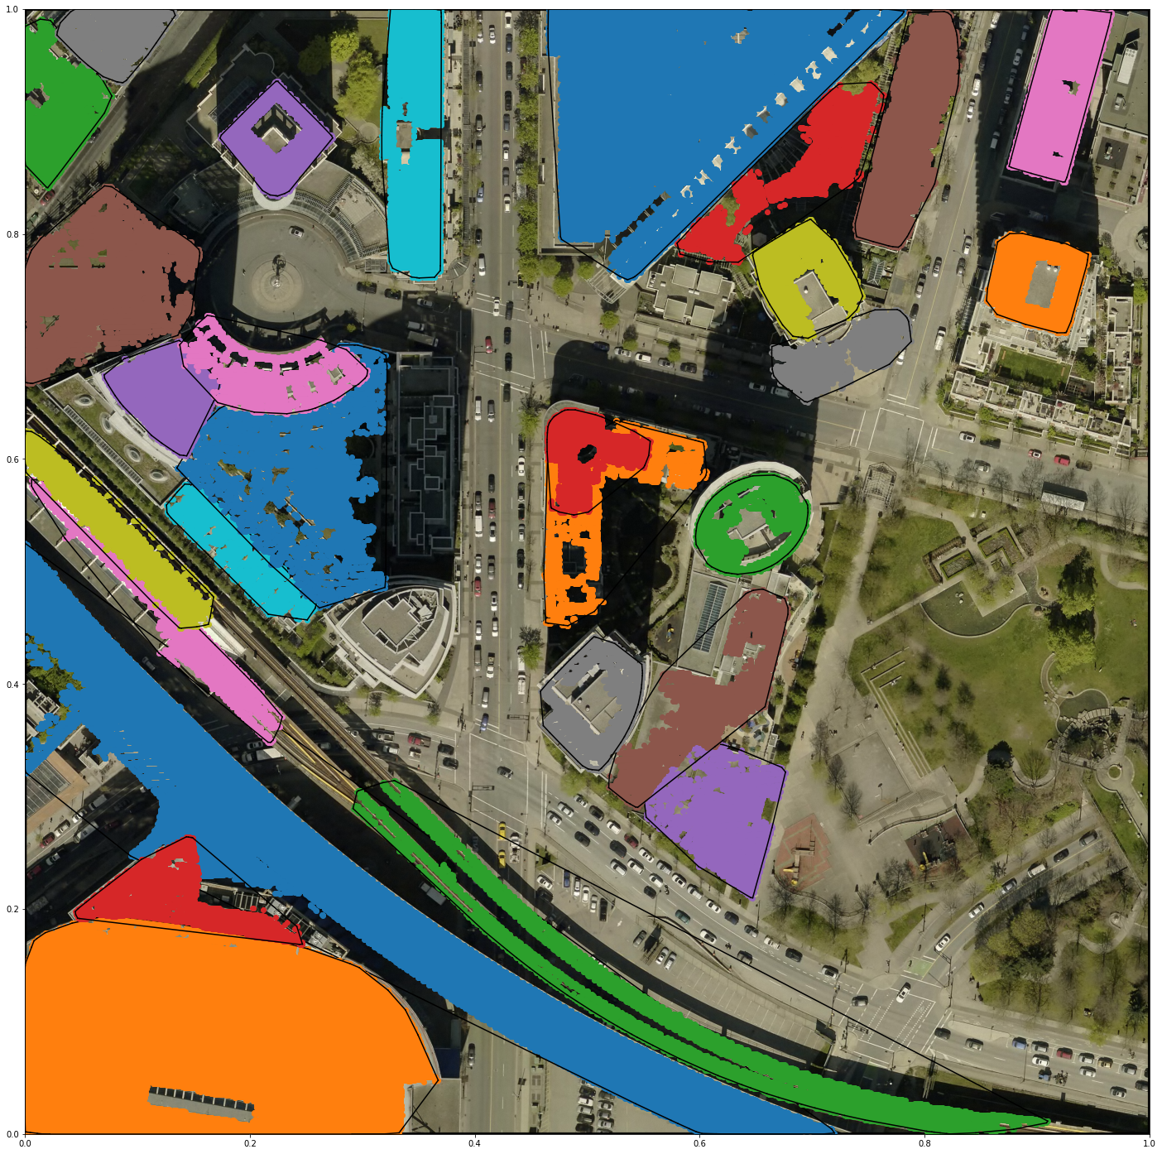

Among these features appear to be raised roadway and viaduct, raised rail tracks, larger building footprints and rooftop features.

All features visualized with classified ground in black:

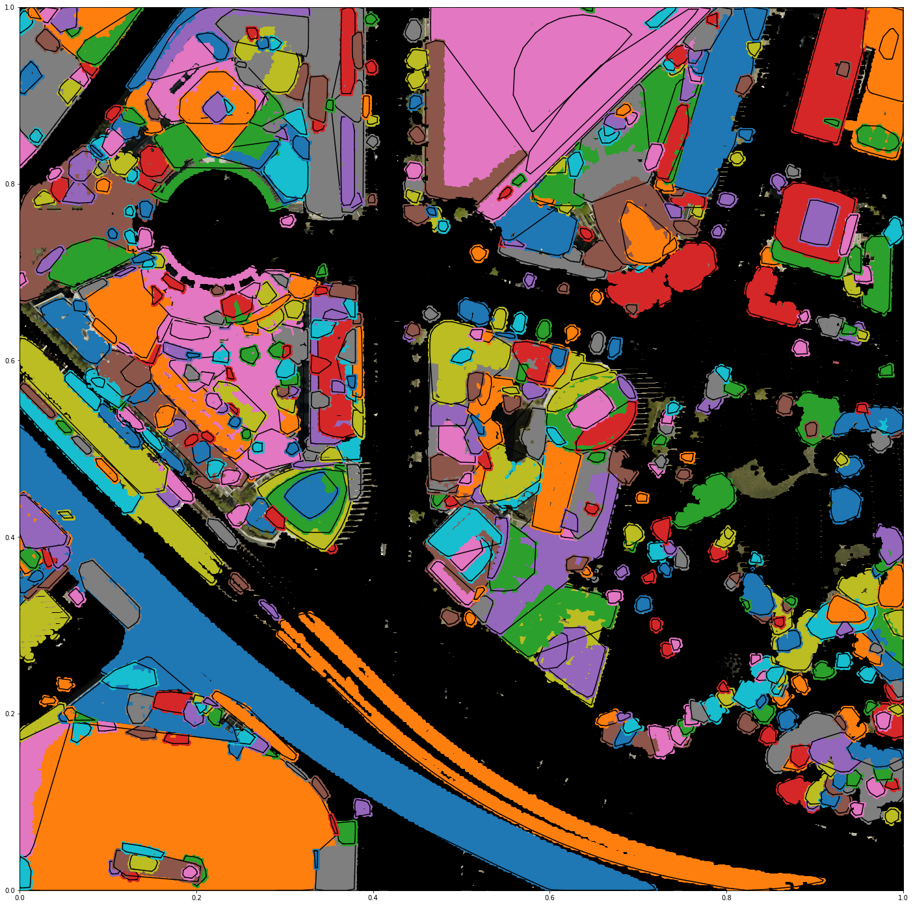

*Notable features identified*

* Large high-rise apartment buildings (potentially clustered into large sections)

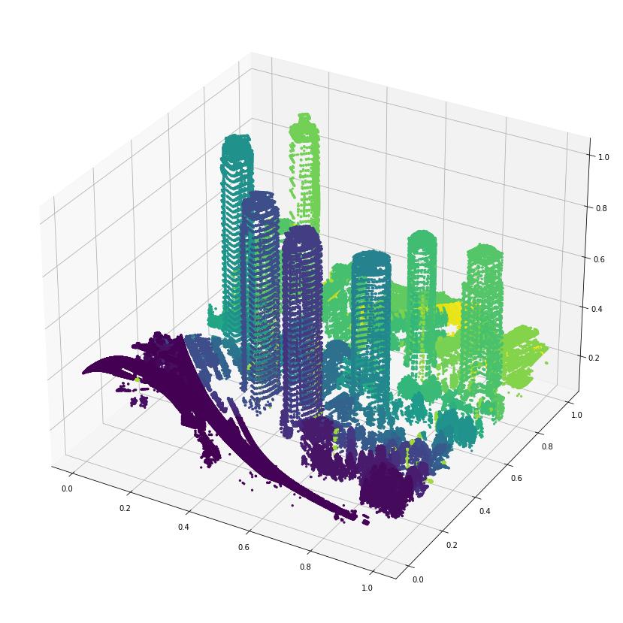

* The clock feature on one of the building was successfully differentiated from the rest of the buildings roof.

** **

* Several rows of trees were identified, along with many other trees:

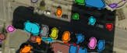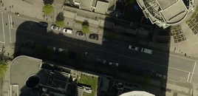 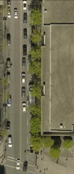 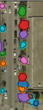

* Major landmarks/buildings and large infrastructure:

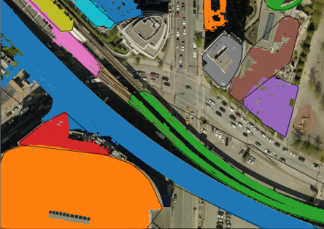 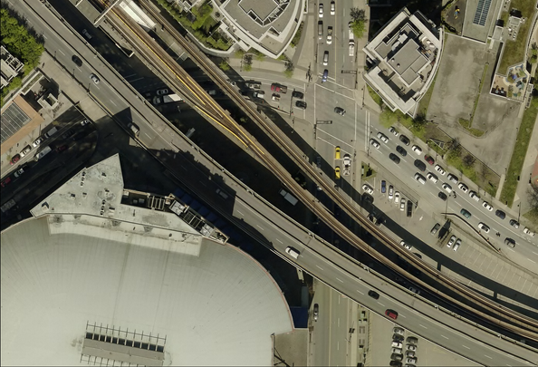

While many clusters have been identified, they are difficult to visualize all of the points, since they are in 3D. I have attempted to improve visualization of the data by exporting the data frame as a csv and importing it into standalone mapping software to view it, using the X,Y,Z coordinates and symbology applied by the cluster id value to colour the points. These screenshots are below and provide a better view of the results.



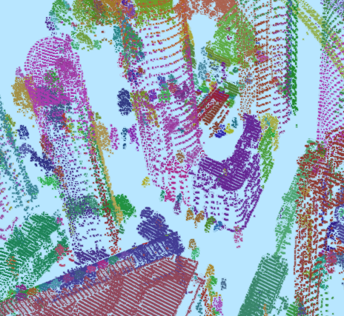

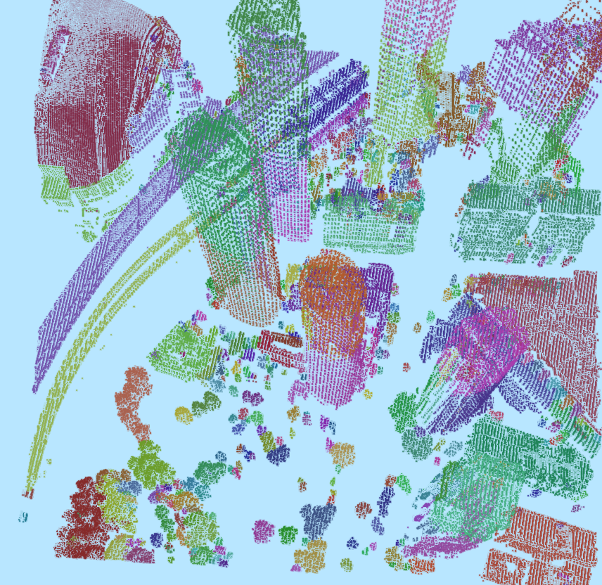

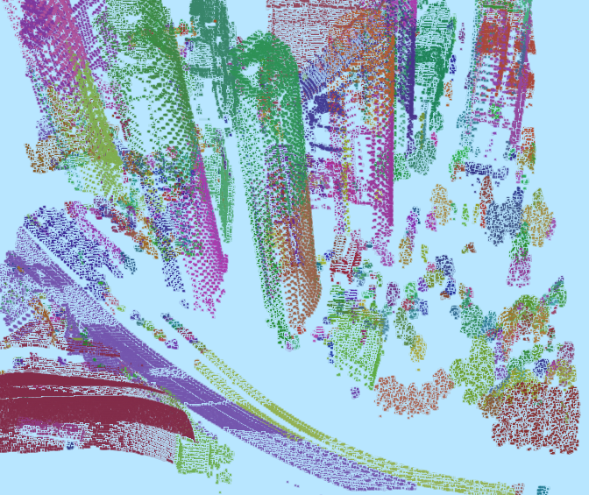

**Shortfalls and next steps**

Some shortfalls of this work include:

* Lack of reliable performance measures for the output and having to rely on visual references
* Shadows in the imagery: caused misclassification of points and improper clustering, seemed to work better without r,g,b although the idea seemed promising
* Difficulty to visualize all data points: since the data is in 3d, it was difficult to fully visualize the data, overhead view can only show a limited perspective.

Some next steps I would perform are:

* Label all the clusters on what they are and retrain a classifier to attempt to classify the points again
* Perform the entire process again on a new dataset using the same model to test the model

**Summary / Conclusion**

In this project, I have attempted a method of identifying groups of points in LiDAR point clouds that correspond to unique objects or distinguishable features in the given area based on common surface type, height and proximity. The unsupervised clustering algorithm k-means was used to classify the points into similar groups of height and surface type, which were then passed into the DBSCAN algorithm along with the coordinate locations to cluster the points further based on proximity to attempt to extract physically connected and unique features. The results prove that it can be completed to a certain reasonable success. Along with this objective, a supervised learning classifier was also used to identify the ground points and was able to reclassify approx. 200,000 additional points as ground that were left unclassified when the data was provided. I believe the goal was accomplished as defined for the project and that the research question was answered sufficiently. The clustering algorithms from sci-kit learn and the workflows performed provide a practical method of identifying groups of similar features in a point cloud dataset, which could provide a starting point for more advanced analysis operations.

# References

1. *Esrine Chehata, Li Guo, Clément Mallet.* **Airborne lidar feature selection for urban classification using random forests**. Laserscanning, Paris, France. ffhal-02384719, Sep 2009
2. *LI Yong, Wu Huayi.* **Adaptive building edge detection by combining lidar data and aerial images.** The International Archives of the Photogrammetry, Remote Sensing and Spatial Information Sciences. Vol. XXXVII. Part B1. Beijing 2008
3. *M. A. Dogon-Yaro, P. Kumara, A. Abdul Rahman, G. Buyuksalih.* **Semi-automated approach for mapping urban trees from integrated aerial lidar point cloud and digital imagery datasets**. The International Archives of the Photogrammetry, Remote Sensing and Spatial Information Sciences, Volume XLII-4/W1, 2016
4. *E. Özdemir, F. Remondino, A. Golkar.* **Aerial point cloud classification with deep learning and machine learning algorithms**. The International Archives of the Photogrammetry, Remote Sensing and Spatial Information Sciences, Volume XLII-4/W18, 2019
5. *D.L. Bool, L.C. Mabaquiao, M.E. Tupas, J.L. Fabila.* **Automated building detection using ransac from classified lidar point cloud data**. The International Archives of the Photogrammetry, Remote Sensing and Spatial Information Sciences, Volume XLII-4/W9, 2018
6. *Biswas Parajuli.* **Machine Learning Algorithms and Applications for Lidar, Images, and Unstructured Data.** Florida State University Libraries, Electronic Theses, Treatises and Dissertations. 2019
7. *Ming-Jer Huang, Shiahn-Wern Shyue, Liang-Hwei Lee, and Chih-Chung Kao.* **A Knowledge-based Approach to Urban Feature Classification Using Aerial Imagery with Lidar Data.** Photogrammetric Engineering & Remote Sensing Vol. 74, No. 12, pp. 1473–1485, December 2008
8. *Xuelian Meng, Nate Currit, Le Wang, and Xiaojun Yang.* **Detect Residential Buildings from Lidar and Aerial Photographs through Object-Oriented Land-Use Classification.** Photogrammetric Engineering & Remote Sensing Vol. 78, No. 1, pp. 35–44, January 2012
9. *Shane Grigsby.* **Spatial Clustering in Python: Processing LiDAR points into objects.** *University of California, Santa Barbara, NSERC*
10. Florent Poux. [**Discover 3D Point Cloud Processing with Python.** Towards Data Science](https://towardsdatascience.com/discover-3d-point-cloud-processing-with-python-6112d9ee38e7). April 2020